
  Environmental Literacy Plan
    - Cherryville N.C 28021 Gaston County




D
Community people gathering During women empowerment day


Community members during the tree planting day together we can win the greenhouse effects Label

Habitats
Types of Habitats:
Using Google Earth, locate your community. Take a screenshot of your community from an aerial view. Mark the habitats on the map. Make a note of habitat degradation, fragmentation, and destruction.

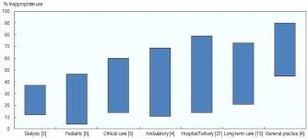

Population
Current Population:
Prediction of Population (in 5 years):
Population per Sq. Mile:
Locate census data for the population of the community over the last 5 years. Plot it on a graph to show how the population has changed over the last 5 years. Based on the information can you predict what the population will be 5 years from now? Include the prediction on the graph as well.

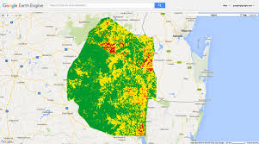
Demographic Information
Does the community attract a seasonal population? Why is this a danger to environment of the community?
Yes. This is dangerous to the environment as it increases demand for private and public goods and services. Consequentially, it leads stress on the natural environment and physical structure.

Median Age and Sex:
The median age of my community is 24.2 according to the US census statistics bureau. The median is 52% male while the remaining 48% is taken by women.

Education:
There is elementary and secondary education enrolment standing at 16%.

Race and Hispanic Origin:
My community comprise of many Hispanics more so black Hispanics. there is limited number of non-black Hispanics.

Housing:
Public housing is the common type of housing in my community. It is done under United States Department of Housing and Urban Development.

Economy:
The communal economy is multifaceted having well networked systems.

Transportation:

Economic Health & Vitality:

How does the demographics of a community affect the environment? Provide three examples:


My community has one center for environmental sustainability. It is known ‘Save Resources for Future Use’. The center endeavors in implementing strategies that can encourage community members to conserve environment and refrain from environmental degradation. The activities include tree planting, encouraging the use of biodegradable materials. According to the efforts of this community center for environmental sustainability, it should be included in the National Parks Department.

Community Environment Center

Community Center Information (Location, Hours, Contact Information)
Community events

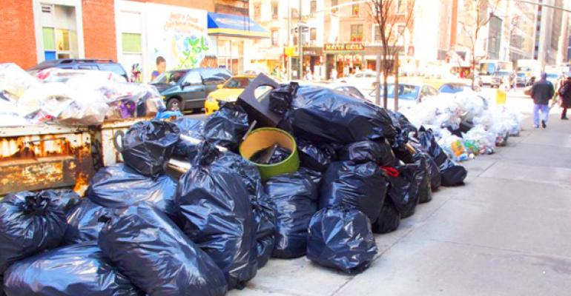


The rise of temperatures in the planet is an issue that is upsetting. It is a consequence of global warming. According to Zehr (2016), global warming stems from the sun reaching the earth. As result the sun heats up the surface of the earth and the atmosphere becomes unbearable due to intense heat. The outcome of intense heating of the earth results into greenhouse effects. This is therefore an issue that requires public concern especially the media to initiate the campaigns that can save the surface of the earth from greenhouse effects. The media is an integral part of the society in the campaign against environmental degradation. The use of fossil fuels in production of electricity is another significant way in which climate change is being seen on the planet.
IMPACT
The women empowerment that has seen women go family planning methods has assisted in controlling overpopulation in my community. The women rights movements within the society have played a key role in achieving these goals. Overpopulation leads to environmental degradation through deforestation. Consequentially this has increased the effects of global warming. So, the choice to uphold women rights has been effective in conserving environment. The choice of the community to use biodegradable material has also reduced pollution of the environment.
Do a local media search to see what types of environmental issues have been covered by the media (Global Warming is a hot topic right now). Include a summary of three (3) articles that you find and describe the nature of those issues. Cite and reference the articles in APA on the References page of the document.

The combustion of these fuels emits carbon dioxide, nitrous oxide, and methane which result into intensive global warming. Deforestation occurs when people go in search of land for human settlement which has increasingly led to adverse global warming effects (Freeman & Freeman, 2014). The implications of global warming continuously causing a huge damage on the earth’s environment. Many human beings are still unaware of the global warming and can hardly see it become serious environmental issue in the near future. Scholars have demonstrated that global warming is and will continuously affect the ecosystem and destroy ecological balance (Powell, 2015. A compelling research has warned that a long-term solution to conserve environment should be devised otherwise human species will suffer a lot.

The Environment in the News

References
Freeman, B. G., & Freeman, A. M. C. (2014). Rapid upslope shifts in New Guinean birds illustrate strong distributional responses of tropical montane species to global warming. Proceedings of the National Academy of Sciences, 111(12), 4490-4494.
Powell, J. L. (2015). Climate scientists virtually unanimous: Anthropogenic global warming is true. Bulletin of Science, Technology & Society, 35(5-6), 121-124.
Zehr, S. C. (2016). Public representations of scientific uncertainty about global climate change. Public understanding of science.

